Keyboard Settings App

Keyboard Settings App should not be the part of keyboard manager app, it should only manipulate keyboard configuration file and then invoke keyboard manager app to reload the configuration file.

1. Button Sensitivity:

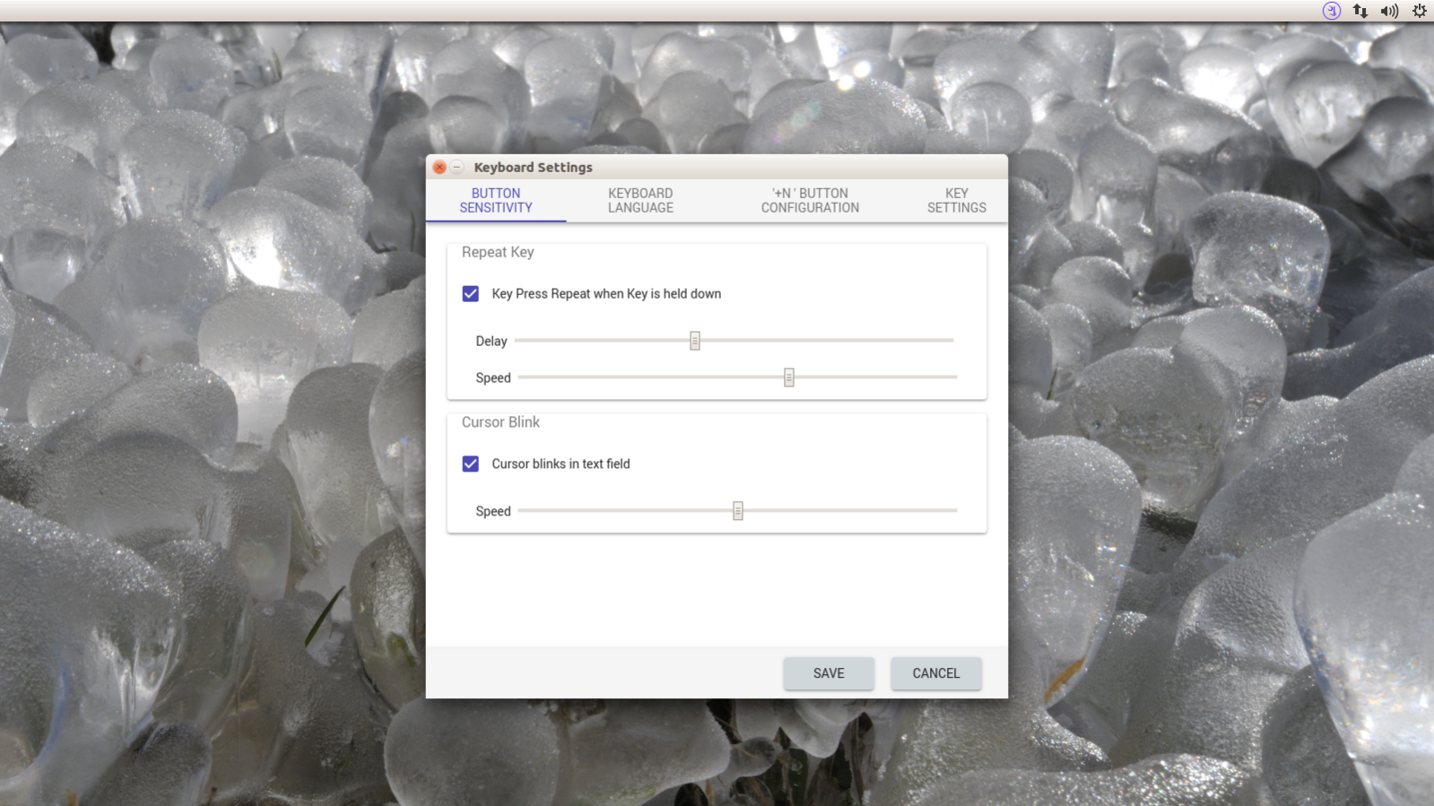

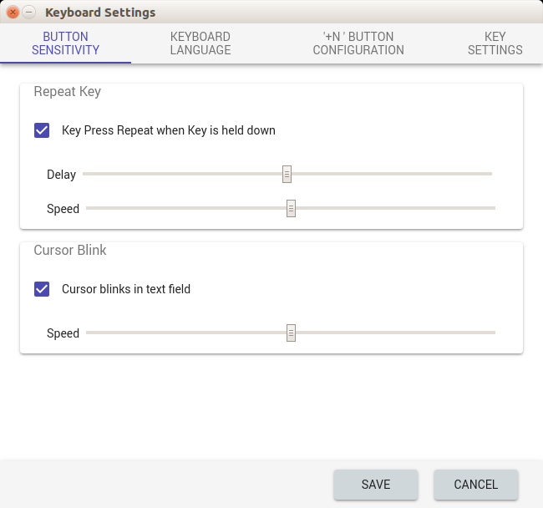

2. Keyboard Language:

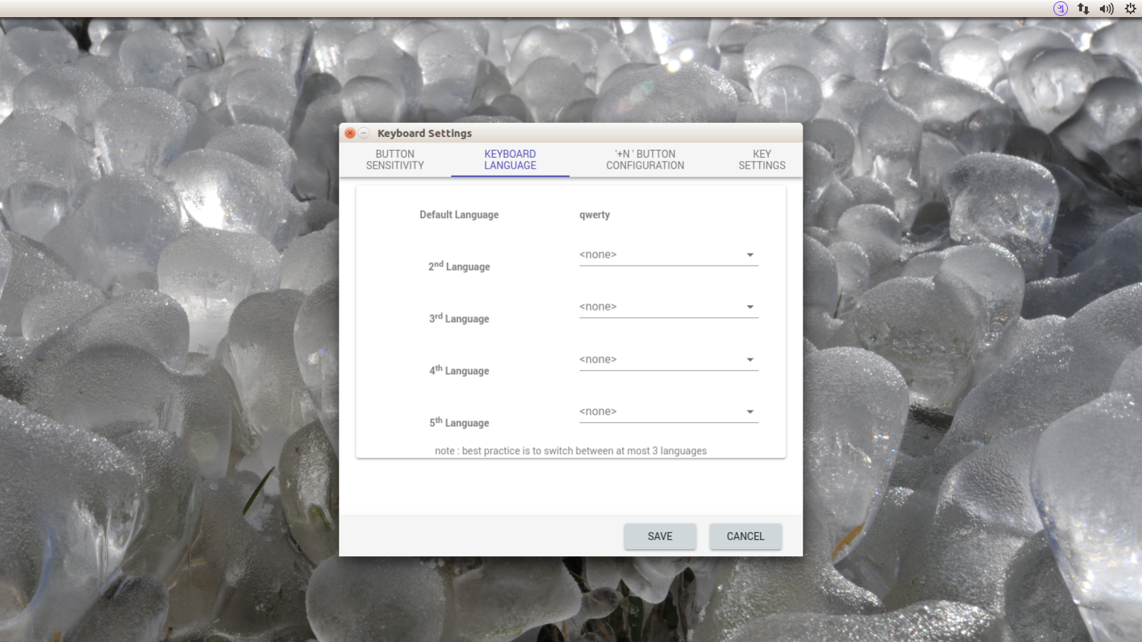

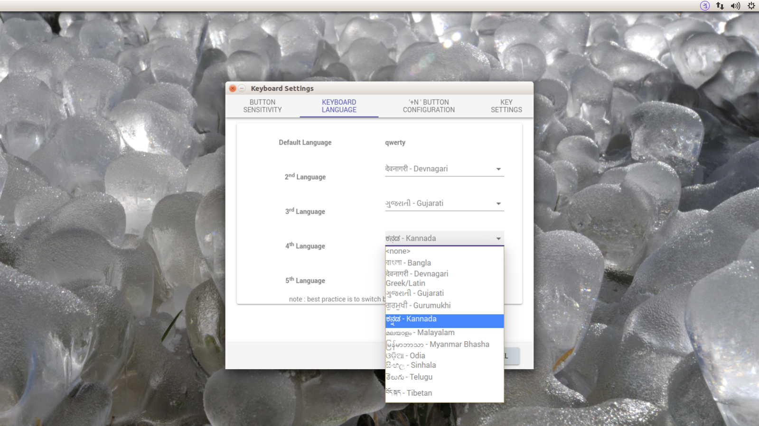

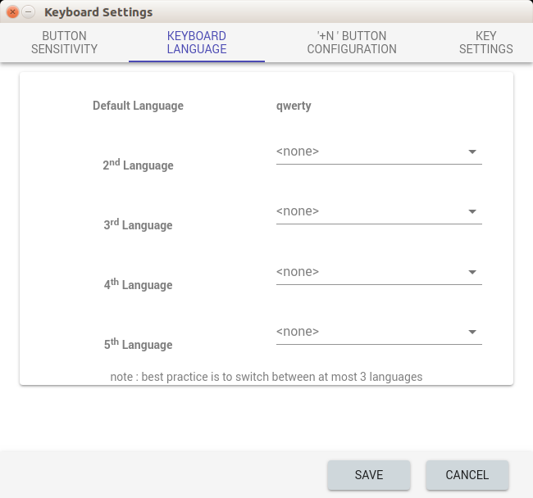

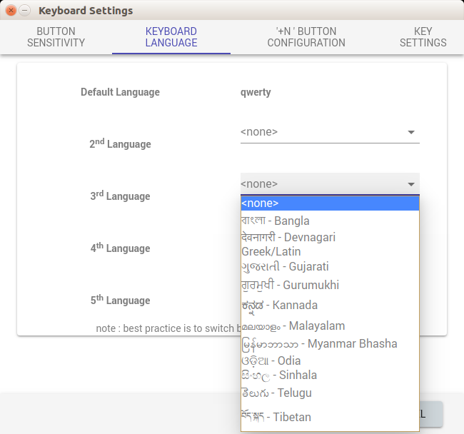

3. Configurable Keys Settings:

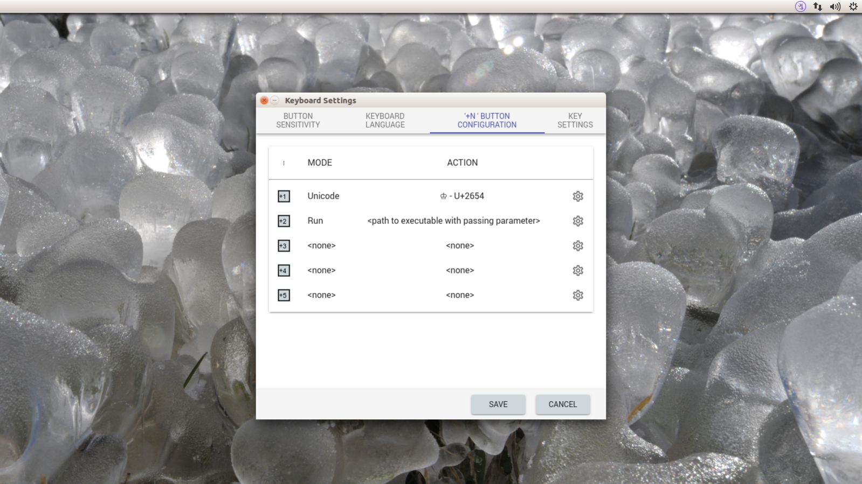

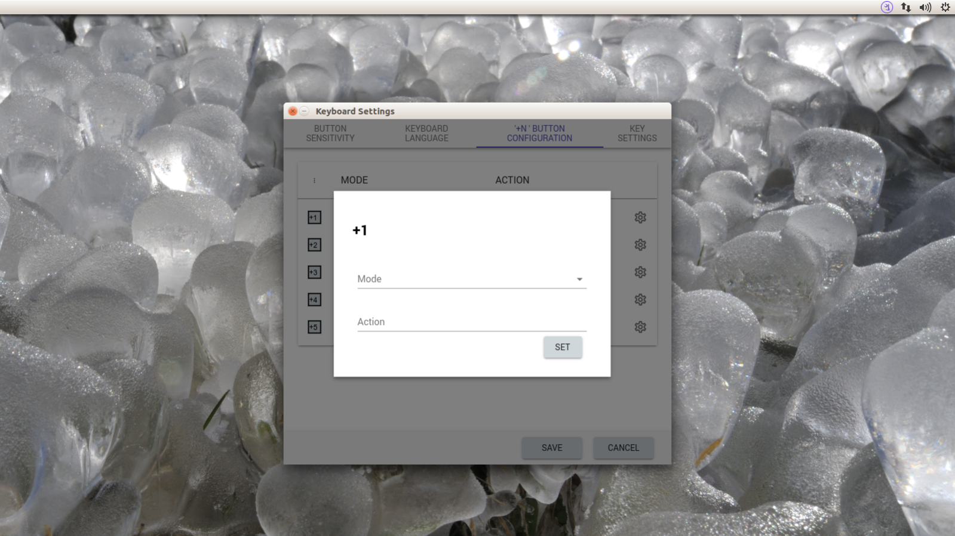

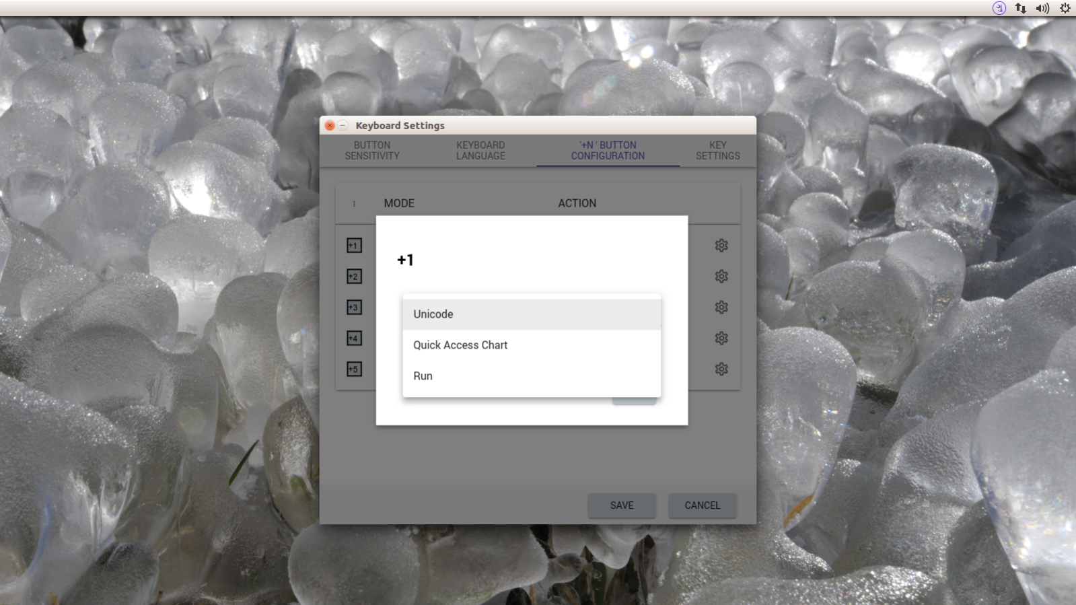

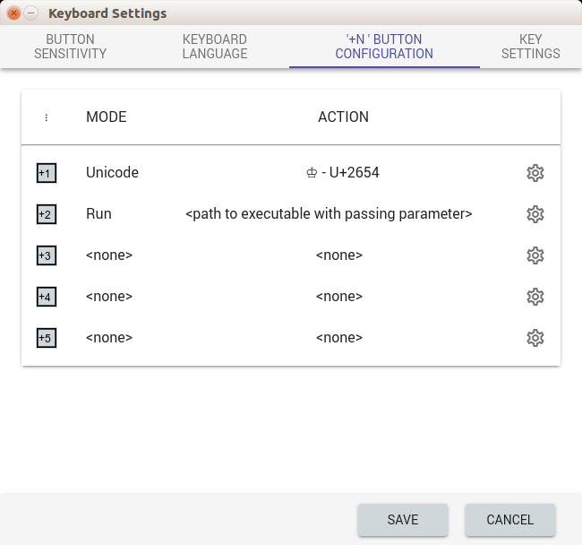

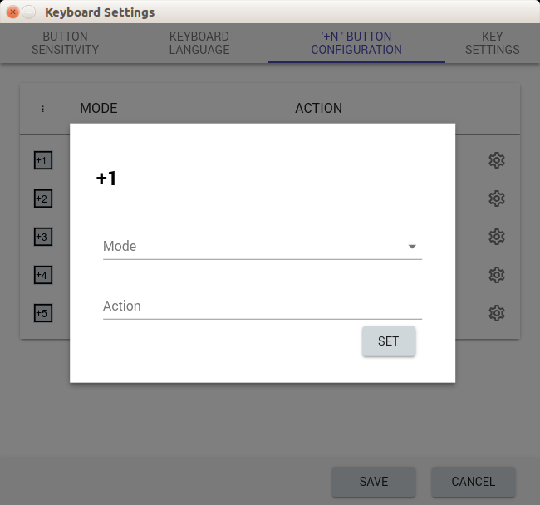

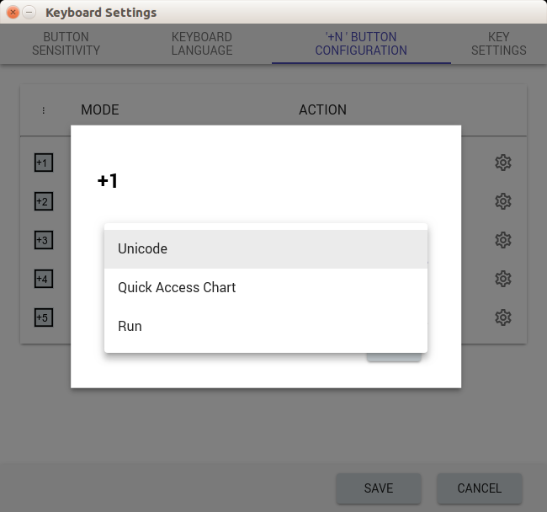

4. Shortcut Key Combination Settings:

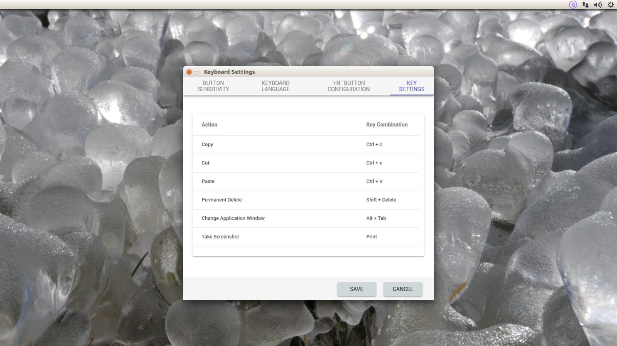

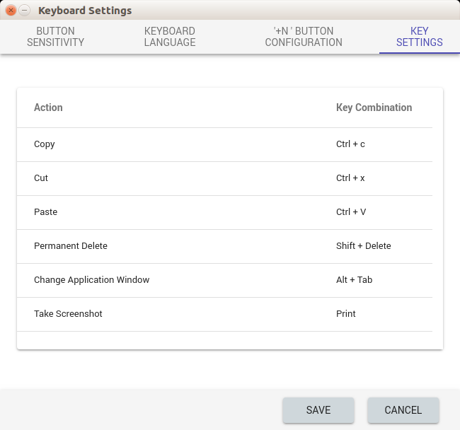

Tray Icon and Drop Down Menu

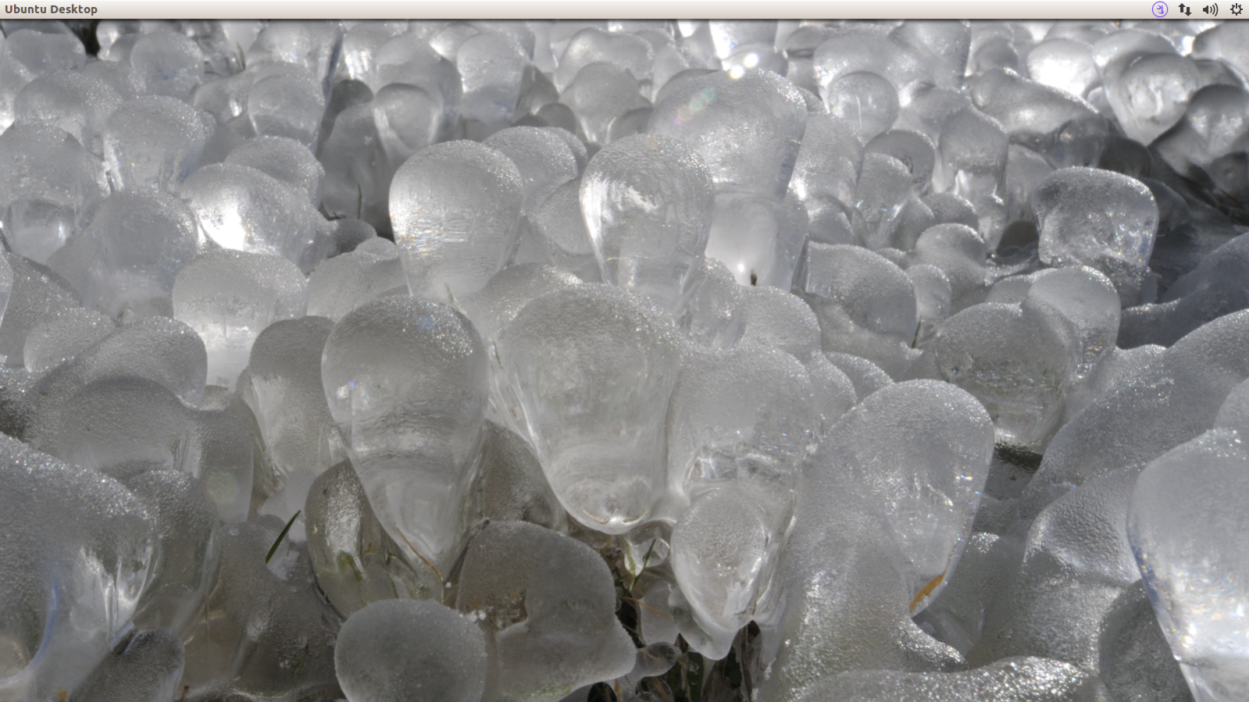

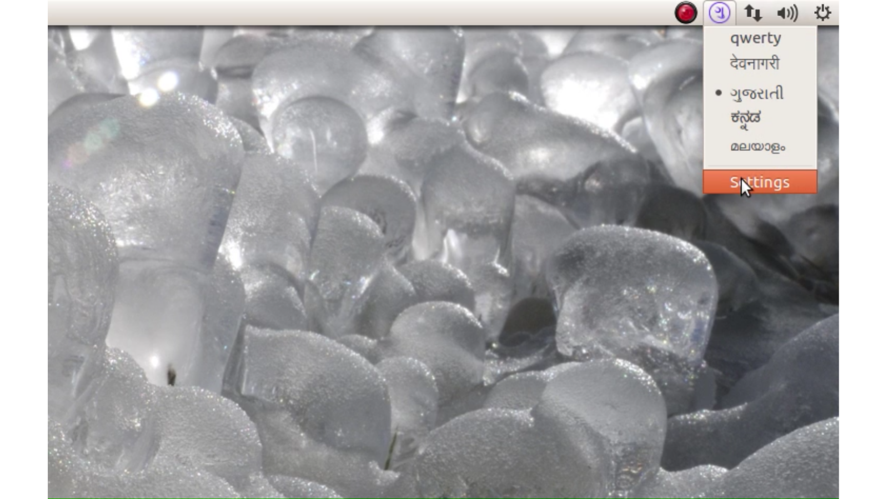

Quick Chart

Quick Chart is the frameless window which opens up with focus when user press one of the Configurable Keys(‘+N’ keys) that is set to ‘Quick Access Chart’. This window will close when window goes out of focus or one of the character is clicked on the chart.This will send the character that has been selected to the window which was in focus before. This is managed by keyboard controller demon which also manages notifier in tray and also contains keyboard device driver. This should not be the part of Keyboard Settings App.

Tab key on keyboard can be used to navigate between tabs (‘RECENT’, ‘FAVOURITE’ and ‘CHARACTER LIST’).

Recently Used Characters:

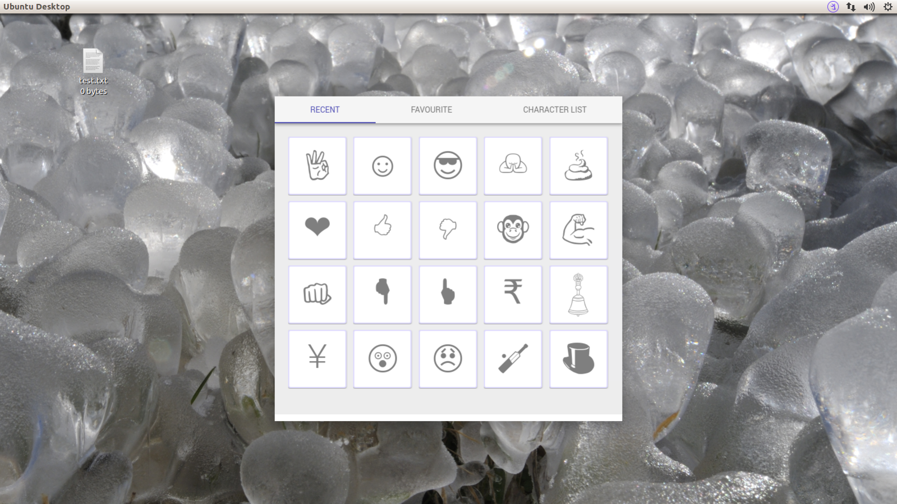

To select the character from ‘RECENT’ tab user can click on the character or can use arrow key on keyboard to choose and then press enter to select. Quick Chart window will close on selecting the character.

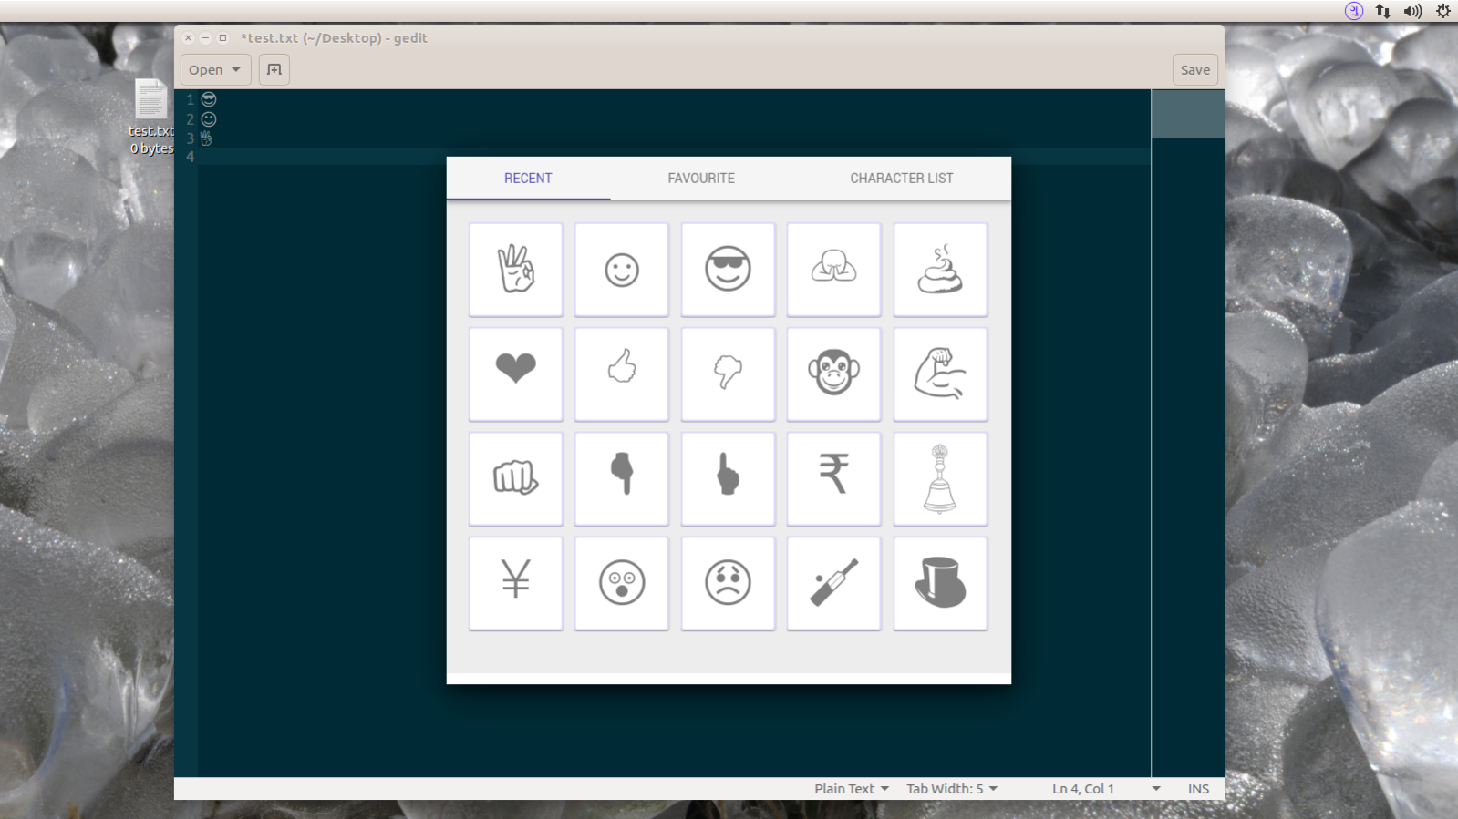

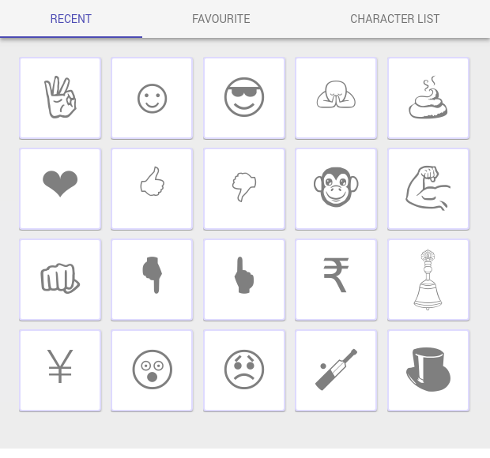

Favorite Characters:

Characters in ‘Character List’ tab which are marked with heart will appear here. This is the list of characters which are used frequently. This is scrollable and any number of characters can be added to the list.

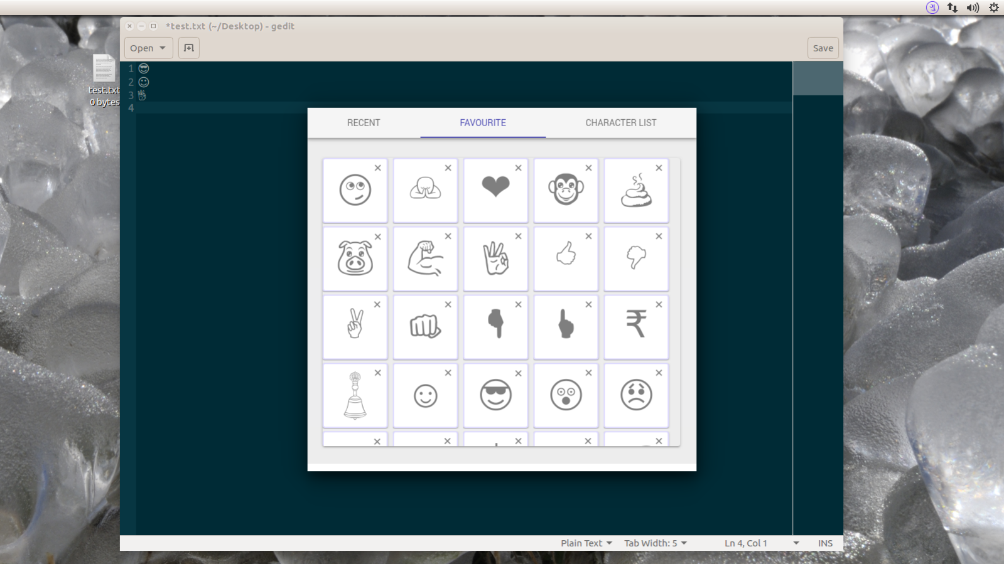

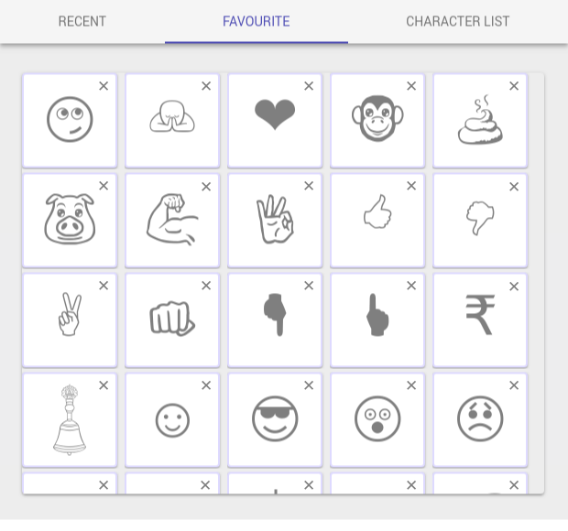

To remove character from the list user can click on ‘x’ mark on right top corner of the character, this will also removes heart mark on character in ‘character list’.

To select the character user can click on the character. Arrow key on keyboard can also be used to choose and enter key to select the character.

Complete List of Unicode Characters:

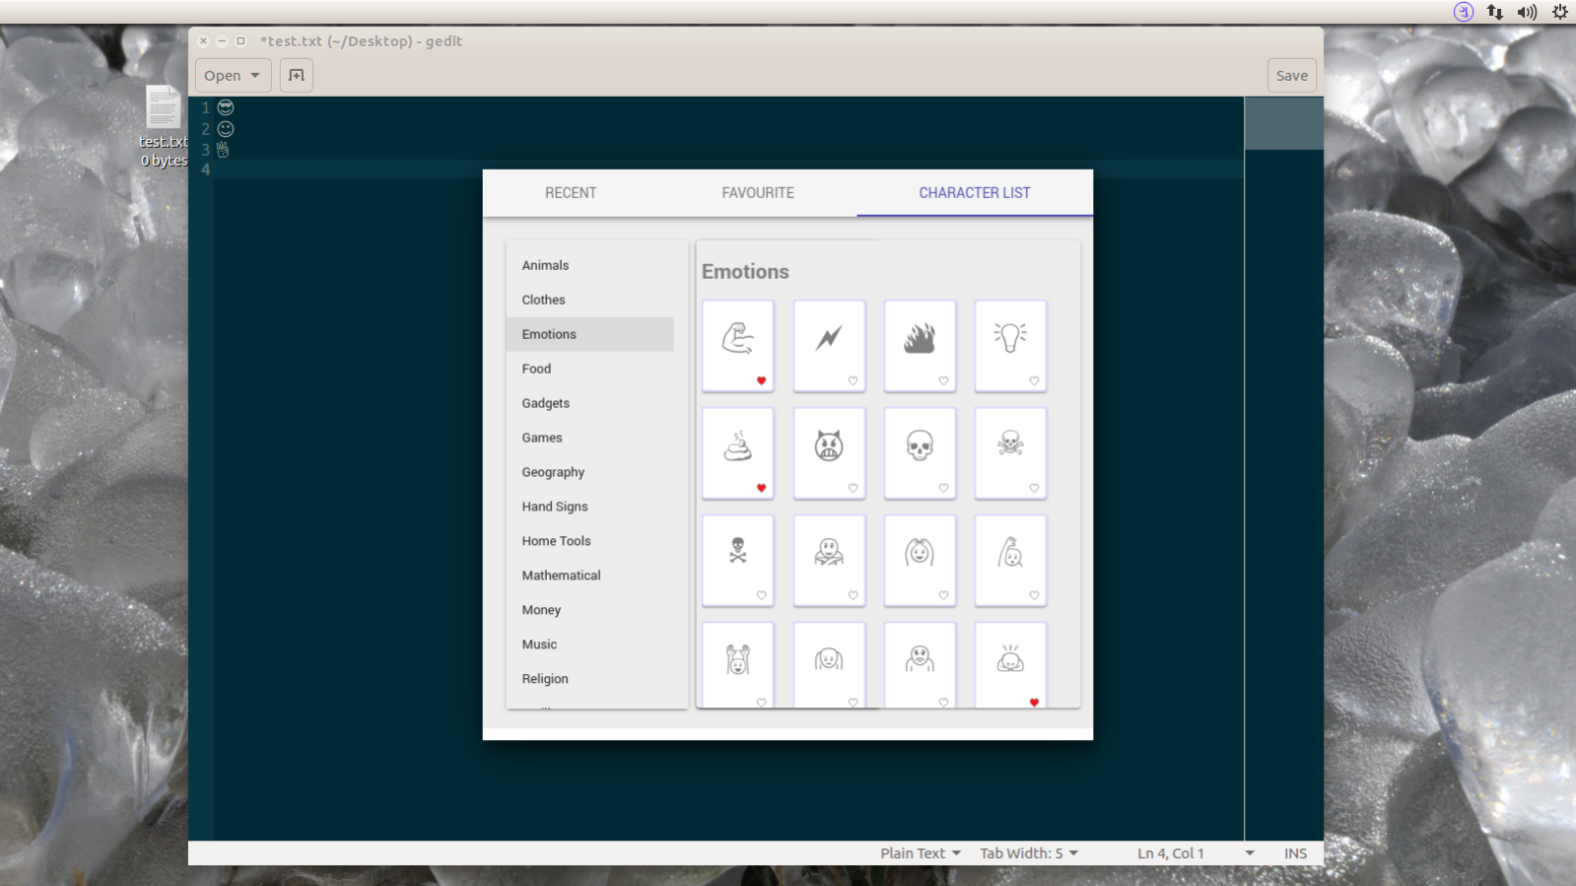

Character List should contain both general purpose characters and other languages.

In the given images only general purpose characters are visible according to their grouping.

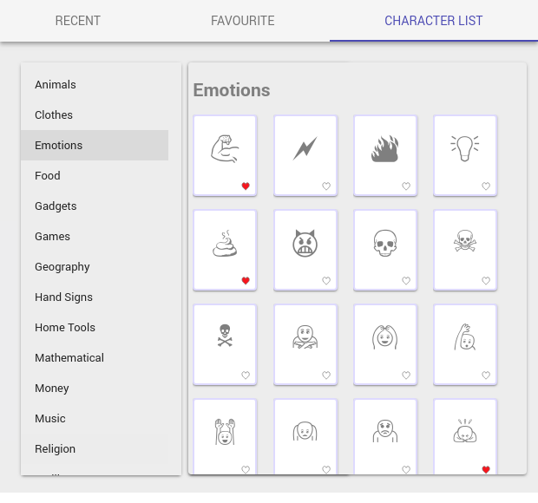

Keyboard Layout

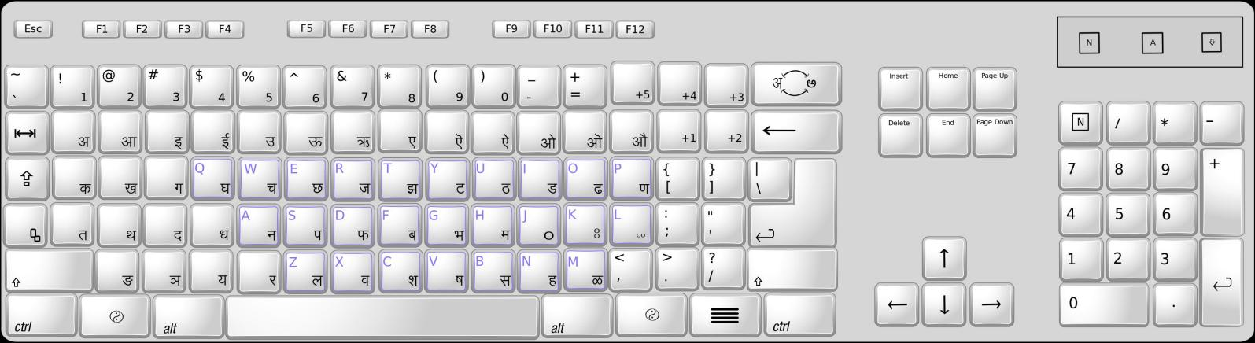

( have a look at the folder of this document to see other language keyboard layouts )

Configurable Keys (+N Keys) :

As of now there are 5 Configurable Keys, this can be changed according to requirement

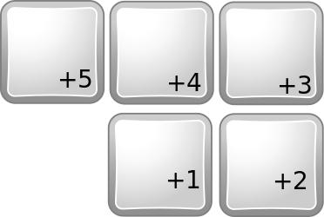

Language Changing Key:

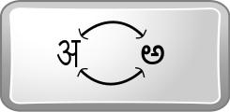

Halant:



Though this button is called Halant it will not just work as halant it acts as more than that.

See image under ‘Halant Usage’ to understand how exactly it should work.

Halant Usage:

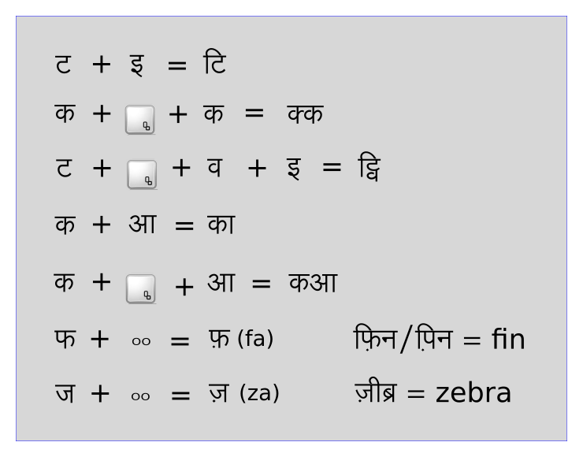

Anusvara, Visarga and Nukta:

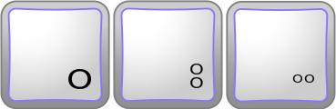

In most of the indian languages anusvara, visarga and nukta are written just as dots which makes it difficult to differentiate between these and full stop. So Telugu and Kannada style anusvara, visarga and nukta is used.

Technology

This should be 100% compatible with existing qwerty keyboard. It should not interrupt or block the existing usage pattern.

This should act like a qwerty keyboard from the time of switching on the computer till the device driver loads the configuration file, only after that it should act like intended keyboard.

‘qwerty mode’ and ‘intended mode’ should be coded in keyboard firmware and default mode should be ‘qwerty mode’. Only after device driver gets loaded it should change it to ‘intended mode’.

When keyboard is in ‘qwerty mode’ the non qwerty keys of the keyboard should be dead and they should not send any signal or message to the computer.